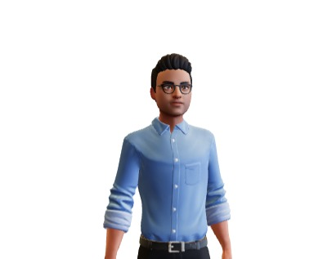

# Get in touch!

### Mobile:

877-037-0333

### Email:

[rbiturwar@gmail.com](mailto:rbiturwar@gmail.com)

### Website:

https://riot0212.github.io/My-Protfolio/

### Address:

Raipur(C.G)

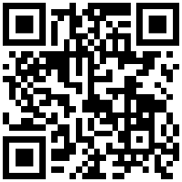

Scan Me

**Rohan Biturwar**

# BIO

A Computer Application Developer, Pursuing BCA from ITM university Raipur (C.G), Willing to work as a cyber security Expert, and to provide a secure datalink and encrypted firewall to the defense force

Educational History

## BCA, ITM University, RAIPUR

**Computer Application Developer Expertise (Cloud Technology)**

Currently pursuing with an aggregate of 80% 2020-2023

## Higher Education

**12th.MGM Higher Secondary School Raipur**

CBSE|2020|61.5%

10th. **MGM Higher Secondary School Raipur**

CBSE|2018|62.4%

# Project

### Student Course Record System

**Java|Sql**

IT is a data entry system specifically designed for institutions and schools to keep the record of the people working over there

### WallMart

**HTML|PHP|Bootstrap|Sql|Javascript**

IT is a software designed for small scale daily need store to keep the record of there data .This works on the database and provide a detailed information regarding the products which helps the owner to get the info regarding the data of the stores that is kept in the shop

# Specializations

* + Django
  + Python
  + Core Java(J2SE)
  + C
  + C++
  + Html,Css,javascript,php
  + Bootstrap
  + MySql
  + Git

# Languages Spoken

Hindi

English